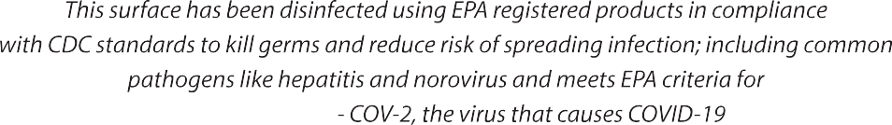

WE CARE

ABOUT YOU

Surfaces disinfected by:

